Material Technologies - Graphics

Pre-visit activities and post excursion resources
To help you understand the technology concepts during your fieldwork, please complete the pre-visit and follow-up activities below.
Pre-Visit Activities:
- Read the Project Design Brief below outlining the requirements for the adaptive reuse of 87 Lower Fort St.
- Read the information below about the location of 87 Lower Fort St and Millers Point in general.
- View the information below about sustainable building design which may give you ideas to include in your 3D building design.
- View the tutorial on Google Sketch-up to familiarise yourself with the CAD software to be used on the day.
- Develop a new use for the building by considering the information in Activity 2 and begin designing a draft interior plan for the new use of the building.
- View the PowerPoint on Designing a logo and begin the process of designing a logo that represents the new use you have created for the building.

Your teacher may also deliver a lesson on investigating insulation materials using a STELR Sustainable House Kit in order to demonstrate the effects of a variety of insulation material for improving sustainability.

Follow up:
Complete your 2D and 3D designs and logo and submit them to The Observatory Hill EEC (your teacher will help you do this)

- Design Brief
Former Older Women’s Network building, Lower Fort St, Millers Point
(Please note, this is a hypothetical scenario)
The Department of Housing, the owner of 87 Lower Fort St, invites individuals or design teams to submit designs for the redevelopment and adaptive reuse of the former Baby Health Centre and Older Women’s Network building. The Department intends developing the site which is currently zoned commercial.
The building is currently derelict but will be developed by a construction company for the Department who own the building and are funding the adaptive reuse of the building. Your designs will be used by the chosen construction company to re-develop the building.
The Department requires:
- a 3D model
- a 2D floor plan
- a short (1 page) presentation describing the thinking behind your design
- a logo for the new use that provides a strong recognisable brand for the building
- a landscape plan for the surrounding grounds

Your designs for the building and grounds should:
- include features that will make the building and grounds more sustainable
- be innovative and attractive
- encourage people to visit the building
- protect aspects of the buildings heritage

Budget
As the Department is keen to develop the building, they have allocated a large sum of money to redevelop it. They are looking for the most creative use of the building.

Market Research
The Department conducted extensive research with:
- surrounding neighbours
- the general public

This research found there was a need for:
- more tourist related activities and amenities
- More services and amenities for the local residential community and visitors

The design should:
- showcase environmentally sustainable design,
- show how old buildings can be adaptively re-used for a new use
- provide for a community need

Deadline for submissions
Three weeks after your excursion

The manager of the Department of Housing looks forward to receiving your designs.

Manager
Department of Housing

- Background to No 87 Lower Fort St Millers Point

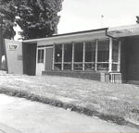
The building at No 87 Lower Fort St was opened on the 22nd November 1952 by the Hon Daniel Clyne MLA as a new Baby Health Centre run by the Department of Health and the City of Sydney.

The 1950s were a time of growth in the Australian economy and most of the housing in Millers Point was owned by the Maritime Service Board, and lived in by wharf labourers and their families.

Most of the men in Millers Point worked as wharfies at the nearby wharves at Walsh Bay and Darling Harbour. Millers Point was a very close-knit and young community.

With less wharf labourers need on ports as they modernised in the 60’s, 70’s and 80’s, the Maritime Service Board decided to hand over all their houses in 1985 to the Housing Commission (now the Department of Housing). The new residents were mainly low-income tenants and the number of young children decreased.

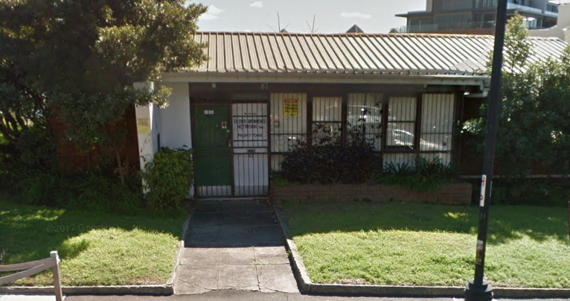
As the population got older, and better medical facilities were available for young mothers elsewhere, the Baby Health Centre was eventually turned into an Older Women’s Network. By the late 90’s even this facility closed and the building has been abandoned for around 20 years.

In March 2014, the Department of Housing announced plan to sell 206 heritage listed properties in Millers Point, and relocate 465 residents to other locations like Glebe, Matraville and Redfern. Reasons given by government included a huge repair bill for the decaying properties and need to build more housing for approximately 53,000 people on a Public housing waiting list.

By 2018 the last public housing tenants had moved out and the properties were being sold to wealthy private buyers. The area has rapidly become a gentrified suburb with individual properties fetching record prices and a wealthier population has moved into the suburb. The infrastructure and amenities in the area have also been upgraded to reflect the new wealthy residents of the suburb.

In addition, the development of nearby Barangaroo and its new train station, as well as the development of the Walsh Bay arts and culture precinct, is likely to see more pedestrians, (including tourists) walking from Circular Quay through Millers Point and past the former Baby Health Centre. This increase in local resident’s wealth, as well as more tourists to the suburb, is expected to bring many opportunities to any developer of the former Baby Health Centre

New park provides pedestrian link to Barangaroo headland
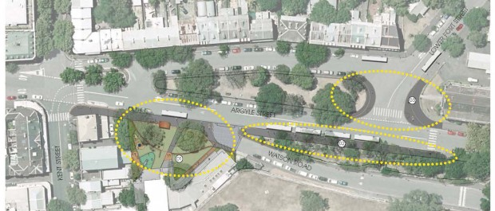
Thursday, April 24th, 2014

One of Sydney’s most historic areas will get a new park and playground as part of a major street upgrade to improve pedestrian access to Barangaroo.
City of Sydney will improve Argyle Street in The Rocks to create a better pedestrian link between Circular Quay and the new headland reserve now under construction on the northern tip of Barangaroo.
As part of the work, footpaths in Argyle Street will be widened and repaved to provide a flat, even surface ideal for walking and pushing prams.
A large bus turning area will be turned into a new park of around 1,000 square metres with a playground outside the Abraham Mott Hall.
New seating will be installed, new trees planted and wheelchair access provided from the park to the Abraham Mott Hall and the Harry Jensen Community Centre. Street lighting will be upgraded with energy-efficient LED fittings.
Up to eight buses currently use the former tram turning area as a layover, and discussions are underway with the State Transit Authority and Transport for NSW about relocating the buses to Hickson Road, Walsh Bay.
Lord Mayor Clover Moore said the changes will be a great improvement for the community in one of Sydney’s most historic areas.
“This sensitive design will maintain the character and identity of Millers Point, a heritage conservation area, while providing more open space and a better experience for pedestrians,” the Lord Mayor said
“When the headland park at Barangaroo is complete, and the commercial area in Barangaroo South opened, many more people will be using this part of the city every day.
“The last big makeover for these streets was undertaken when tramlines were laid, which is why the roadways are so wide. These improvements will change that by widening the footpaths and making the walk to and from Barangaroo safer and more appealing,” she said.
Plans were presented to Council follow extensive community consultation that saw 30 submissions from the public. The Millers Point Leaseholders Groups said the bus layover dominates the public domain and they welcomed its proposed removal.

3. Sustainable (Green) Architecture and Design
According to some estimates, buildings account for almost one-half of the world's material and energy consumption, one-sixth of fresh water use, and a quarter of all wood harvested. Sustainable (green) buildings are designed, built and managed to have a minimal impact on the environment. A green building saves money, energy, water and resources while creating a happy, healthy and sustainable environment. There are many ways to make a building more sustainable include the following:

1. Building on the right site
A green building should not impact on sensitive habitats like wetlands, waterways or old growth forests. Many new green buildings are purposely built in brownfields (built up areas or old industrial sites) to reduce their environmental impact. Green buildings are often located near public transport (to encourage the building’s users to use public transport) and have small building and carpark ‘footprints’ to leave more room for landscaping. This landscaping should include non-invasive native plants (that help promote biodiversity by providing food and homes for indigenous species) and possibly ways to capture and reuse stormwater.

2. Designing and situating buildings to minimise energy use.
Lighting, heating, cooling and ventilation all contribute to a building’s energy use and create greenhouse gases when sourced from traditional energy sources like coal fired power stations. Energy efficiency is a key feature of green buildings which are situated to reduce the amounts of energy required for heating and cooling. Using renewal energy technology like solar and wind helps reduce green house gas emissions, as do simple practices like moderating summer and winter thermostat settings or installing efficient appliances like those with energy star rating certification.
Any way to control temperature without using electricity helps increase sustainability. Good quality window insulation and coverings helps control heat whilst positioning windows to capture sunlight reduces the need for lighting and provides solar warmth in cooler weather. New insulation technologies like Insulating Concrete Forms (ICF) and Structural Insulated Panels (SIPS) greatly enhance energy efficiency. Strategic landscaping can also save energy through smart placement of shade trees and green roofs, which provide additional insulation and reduce stormwater runoff.

3. Using Green Materials
Buildings materials can contribute to sustainability. Green buildings are often made of sustainable building materials including recycled or recyclable materials. Locally sourced materials, particularly those sourced from the building site itself, help to increase sustainability by reducing transport distances and greenhouse gases. Examples include adobe, rock and gravel. Materials such as bamboo, straw bales, cork, and recycled denim insulation, come from sustainable or low-impact sources and contain few or no toxic substances or finishes.

4. Reducing indoor pollutants
The Environmental Protection Agency estimates that indoor air can be up to 100 times more polluted than outdoor air. Volatile organic compounds (VOCs) from some paints, carpets, synthetic fabrics and adhesives are a known health hazard, contributing to sick building syndrome. Proper use of heating, ventilation and air conditioning can help, as can windows that open to let fresh air in and bad air out.

5. Increasing water efficiency
Green buildings help save precious drinking water by minimising water use or reusing water. Some smart uses of water include low-flow toilets, sinks and showers, reusing of graywater (non-septic water from sinks and showers) to flush toilets and irrigate landscaping. Some green buildings even take advantage of rainwater, collecting it to cool the building and incorporating it into natural water features on the site.

6. Reusing old buildings
Some of the greenest buildings are older buildings that have been adapted for reuse. Examples include turning an old warehouse into housing, or a factory into a cultural centre. By ‘retrofitting’ older buildings with innovative sustainability features, it gives them a new purpose, preserves cultural heritage and improves sustainability by reducing the amount of resources required and the amount of waste generated from construction.

7. Amenities and Management
The very best green design and construction ideas don't mean much if the occupants of a green building ignore sustainable practices. For example, recycling and turning off lights when not in use requires ongoing participation from a building's occupants and management. Effective use of sustainability features and amenities, like air conditioning, showers, window shutters and blinds, recycling bins or bike racks, can help make a good building great.From: About.com / Green Living / Green at Home by Marc Lallanilla

http://greenliving.about.com/od/architecturedesign/tp/green_buildings.htm

4. Google Sketchup Tutorial
https://www.youtube.com/watch?v=UsHRGDvN4sM

5. Floor plan
You may wish to create a more professional one at www.floorplanner.com

You will be using an iPad app called Home Design on your excursion to create a professional 2D and 3D plan.
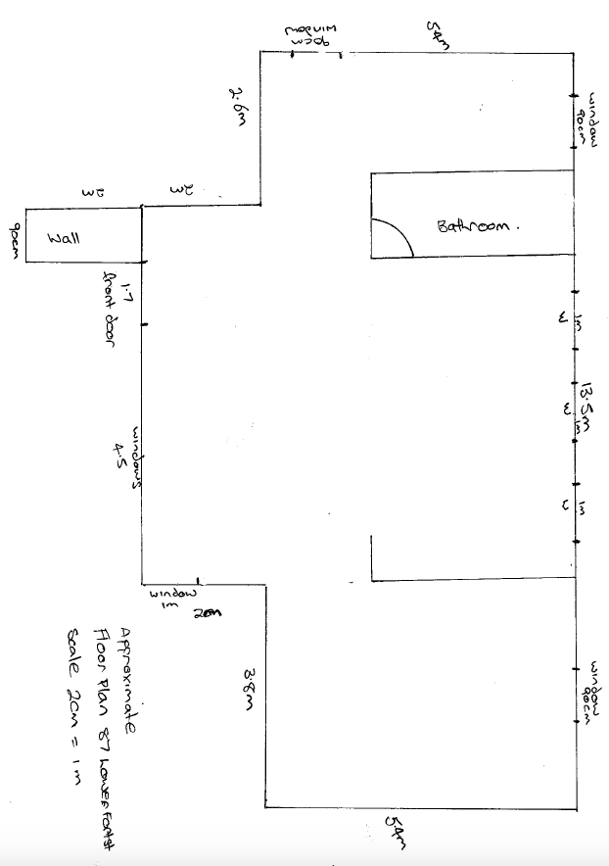

6. Designing a logo
View the presentation Designing a logo and follow the steps to make a logo for your new use for 87 Lower Fort St.

