**Sustainability**

*Action Process*

*Project / Unit of work*

*Kitchen Gardens*

EVALUATING AND

REFLECTING

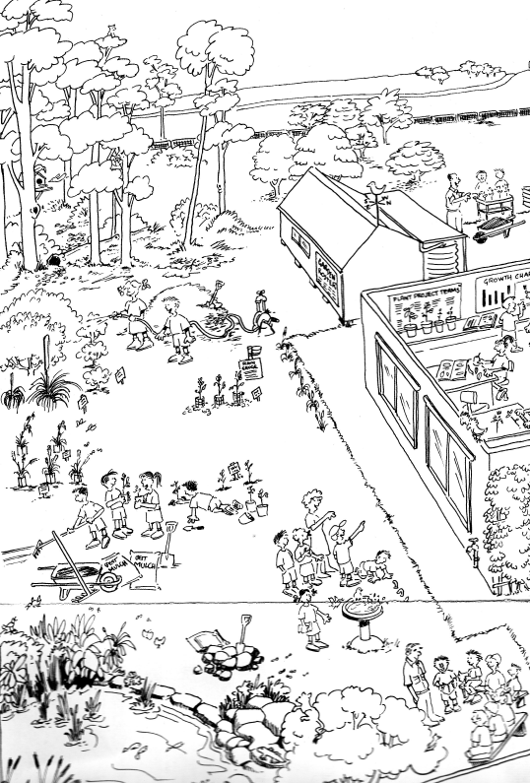

* To put a proposal into action you need to follow the sequential steps, monitor your progress and collect data to help measure your success.

* Our school and the community can undertake a range of actions to grow some of our foods that are suited to our climate and seasons and will grow with the resources we can provide.

***Focus area:***

Investigating sustainable and healthy food production in your local area

* You need to be able to judge and measure the success of your proposal in addressing the original issue and achieving your goal.

* A proposal for growing foods in our school requires: a clear statement of action, criteria for success and agreement by stakeholders.

* Our schools and local communities can produce foods in a garden called a ‘kitchen garden’. These foods can have a lower environmental impact than foods transported over long distances, or foods stored for long periods or foods available out of season. Growing these foods has learning and other benefits.

2

1

MAKING THE CASE FOR CHANGE

DEVELOPING THE

PROPOSAL

FOR ACTION

DEFINING

THE SCOPE FOR ACTION

5

IMPLEMENTING THE PROPOSAL

4

3