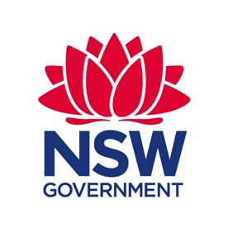

Invitation to attend a professional learning day – 5th June, World Environment Day

Eco-Schools Australia - a platform for whole school student environmental leadership

Are you looking for an exciting opportunity to support your school’s sustainability journey, enhance your student’s environmental leadership, and be part of a global network of schools working towards improving their ecological footprint? Teachers are invited to attend a one day, NESA registered, professional learning course, that will increase their confidence to act as facilitators of a whole-school, student-led, environmental program. The DoE endorsed Eco-Schools Australia program is a structured step-by-step program that will help you to better support your school’s sustainability journey. What better way to celebrate World Environment Day.

This professional learning day includes 5 hours of registered learning.

COURSE DETAILS
DATE | Friday 5nd June 2020 - World Environment Day
TIME | 8.30am - 3.00pm
LOCATION | Summer Hill PS, Moonbie St, Summer Hill, NSW, 2130. Off street parking is available and the school is a short walk from Summer Hill railway station or the Lewisham West light rail station.
COST | $30 (includes morning tea and lunch)
PRESENTERS | Glen Halliday, Principal Observatory Hill EEC, Marina Antoniozzi, National Programs Manager Eco Schools Australia, Observatory Hill EEC staff
REGISTRATION | Course title: Eco-Schools Australia - a platform for whole school student environmental leadership  Identifier: RG04758 https://myplsso.education.nsw.gov.au/q/RG04758
INFORMATION | During the program participants will:  - Discuss present structures and features of Eco-Schools Australia, including the 7 Step process towards obtaining the three award levels, Bronze, Silver and Green Flag.  - Conduct an ‘eco-snapshot’ in a real school environment, addressing four areas: energy, waste, water and biodiversity.  - Discuss and share practical strategies to maximise whole school engagement and success.  - Examine strategies for using school eco-snapshot data to facilitate students through the process of developing an action plan in line with the Eco-Schools Australia framework.
For more information about the program, visit https://www.eco-schools.org.au/

