Watch Our Watts

Pre-visit activities and post excursion resources
Successful incursions have direct links to current classroom learning. Pre-visit activities carried out prior to the excursion will help students better understand their incursion content and provide connectedness and relevance to classroom learning.
To help students understand the Science and Technology concepts during their incursion, you may like to complete some of the pre-visit and follow-up activities below.

Student Pre-visit activities
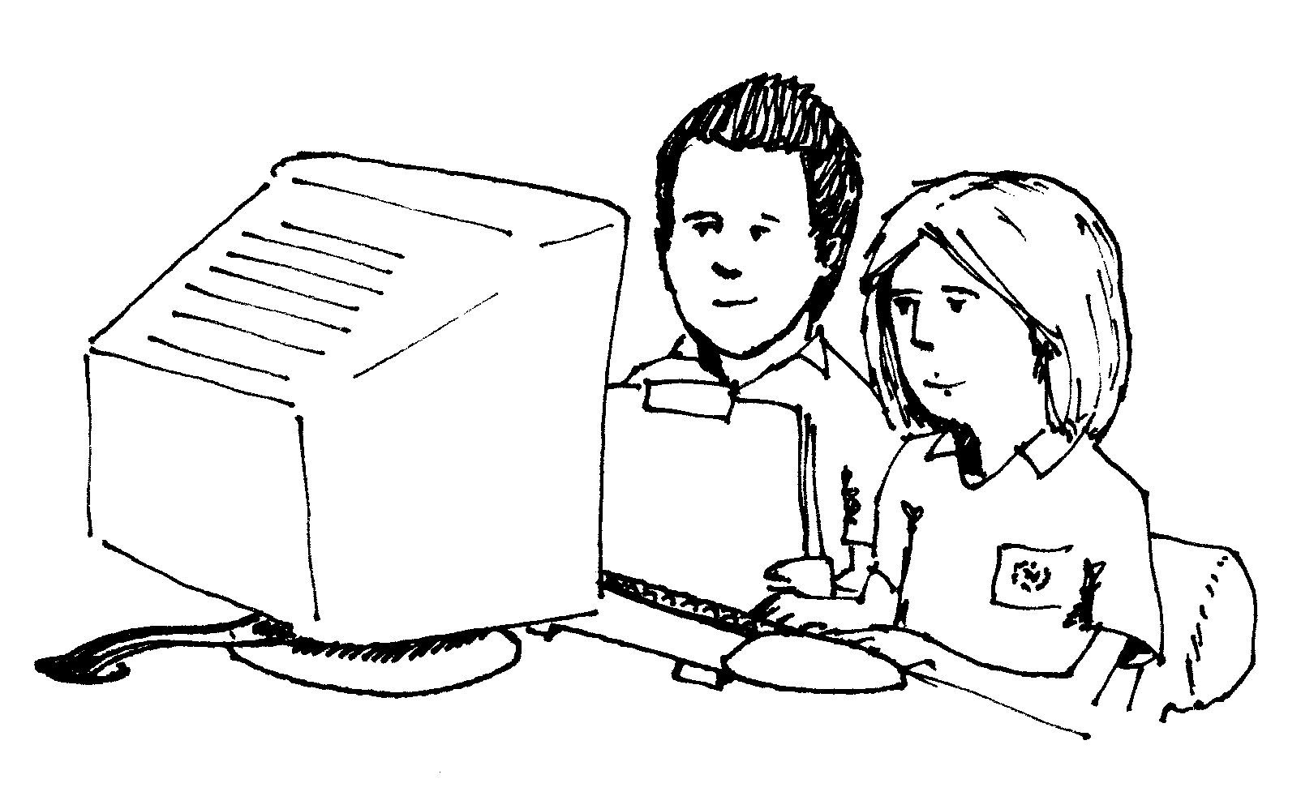
Use the following website to introduce student to the concepts covered on the day http://epa.gov/climatechange/kids/index.html

On browsing the website you may wish to discuss with your class:
- terms associated with the environment such as: global warming, greenhouse gases, carbon footprint, renewable and non renewable resources
- the link between burning fossil fuels and global warming
- the importance of caring for the school and home environment
- ways people can change the environment that can have a positive or negative impact.

Follow up Activities
- Investigate energy efficiency strategies for home.
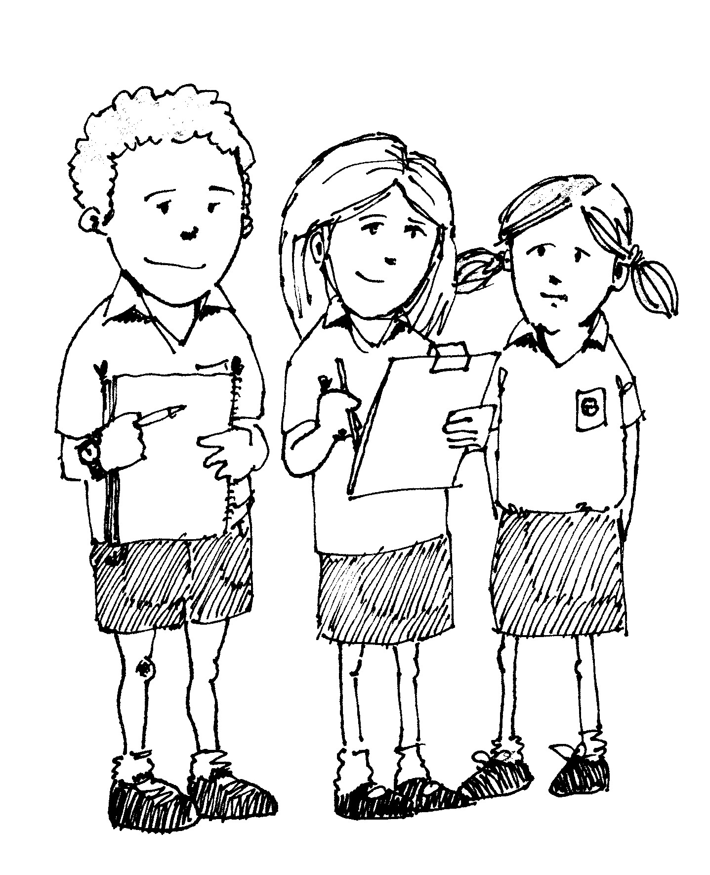
- Allow students to complete their Energy Efficiency Management Plans and make a school plan that can link to the School Environmental Management Plan (SEMP)

Plan activities could include:
- monitoring the efficient use of lights and appliances
- checking things are turned off when possible including the holidays
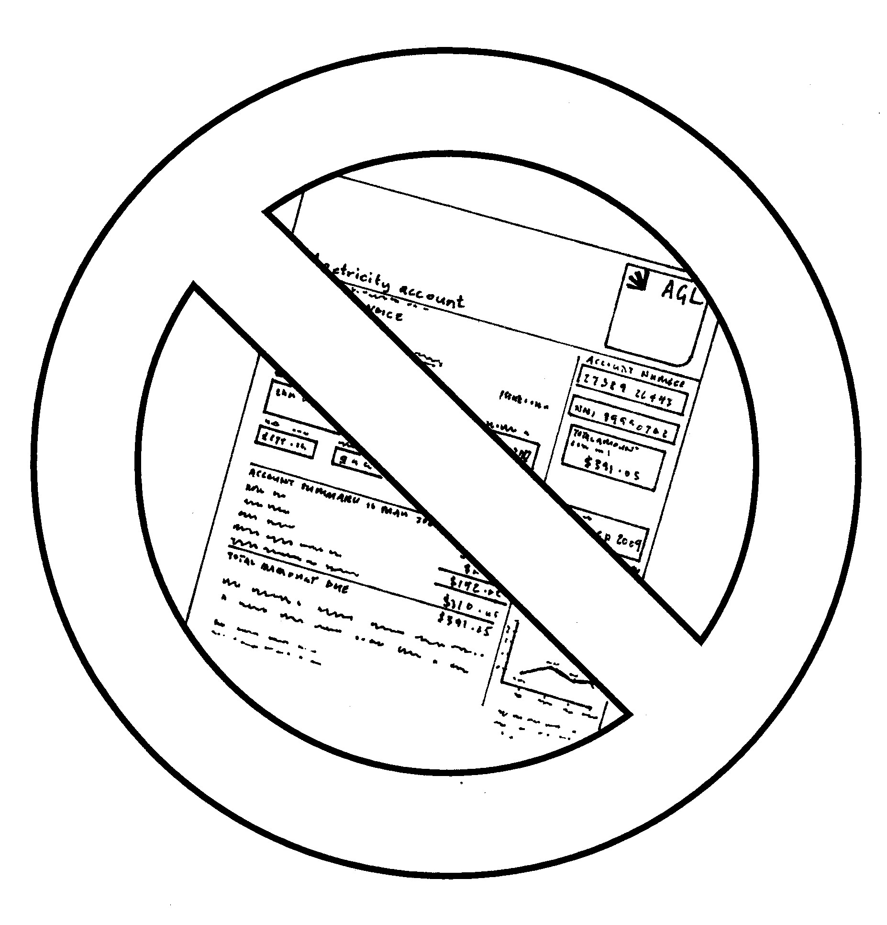
- monitoring the energy bills or Webgraphs to assess total energy used, CO2 produced and any impacts bills or graphs
- Showing progress on energy reduction via graphs or charts, or in the school newsletter
- devising ways to keep students motivated to be energy wise eg class awards/individual awards prizes, designing promotional materials, stickers for lights, an energy mascot’ etc.
- informing the school community how energy consumption produces CO2 which leads to global warming eg library display, article in newsletter, presentation on school assembly etc
- conducting a transport survey to focus on the impact of travel to and from school and devising ways to minimise travel emissions from the school community
- conducting an appliance audit (see pack) to calculate the wattage used in a typical week / month / year etc.

