First Contacts - Barangaroo

Teacher checklist

Meeting point /time | Argyle Street at 9:45am
Finishing point /time | Argyle Street at 2:15pm (please advise the EEC prior to fieldtrip if there are any changes required to the finishing time).
Approximate walking distance | 1.6km over a reasonably flat terrain, with some stairs. There is a wheelchair accessible version of this fieldtrip.
Transport | Bus drop off and pick up for the fieldtrip is on Argyle Street.
Risk management advice | Please see the First Contacts - Barangaroo risk management plan document on the OHEEC website.
Clothing | It is preferred that students are in a school uniform for easy identification in the city.  Sturdy walking shoes are also recommended.
What to bring | a water bottle, hat and sunscreen or appropriate wet weather gear, mobile phone or camera to document the fieldtrip.
Food | Students must bring their own food. There will not be opportunities to purchase food on this fieldtrip.
Staffing | It is expected that teachers actively supervise their class throughout the day to support student learning and behaviour management.
Extreme or wet weather | If there is a need to cancel on the day, please leave a message by dialling 9247 7321 as early as possible or The Principal on 0400 230 699.
Cancellations | Cancellations need to be made within 2 weeks of the date of the fieldtrip or a cancellation fee $40.00 per class will be charged. If cancellation occurs due to inclement weather on the day, no fee will be charged. If there is a need to cancel on the day, please leave a message by dialling 9247 7321 as early as possible or The Principal on 0400 230 699.
Medical or special needs | Please advise OHEEC staff of any student with special needs when booking the fieldtrip (e.g. special mobility requirements). Please ensure that required medications for students are brought on the day and communicated to staff (e.g. epipen and individual anaphylaxis plans). EEC staff carry a basic first aid kit, however, teachers should also bring required first aid equipment.
Pre-excursion activities | Pre-visit activities carried out prior to the fieldtrip will help students better understand their fieldtrip content and provide links with classroom learning.  Please see First Contacts - Barangaroo program page on the OHEEC website for activities.

First Contacts - Barangaroo
Summary of Learning Sites and Activities
Please note: program is subject to change depending on rotation of classes, site availability or other external factors such as weather.
Time | Learning Site | Activity | Students will be able to
9.45 -10.00 | Meet at Argyle Place and walk to first activity
10.00 -11.20 | Barangaroo Reserve  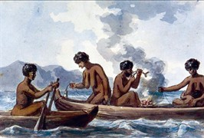 | 1. Pre-contact Aboriginal era  - Listening to story about Gadigal Aboriginal culture  - Identifying native plants with their traditional Aboriginal uses and creating an artwork  - Making an artefact from traditional materials  - Learning about change over time in the area | - Describe people events and actions related to world exploration and its effects.  - Describe traditional Aboriginal ways of life  - develop an understanding and empathy with aboriginal culture
11.20 -11.50 | Recess (incl. walk to next activity) | Barangaroo Reserve
11.50 -12.45 | Parbury Ruins  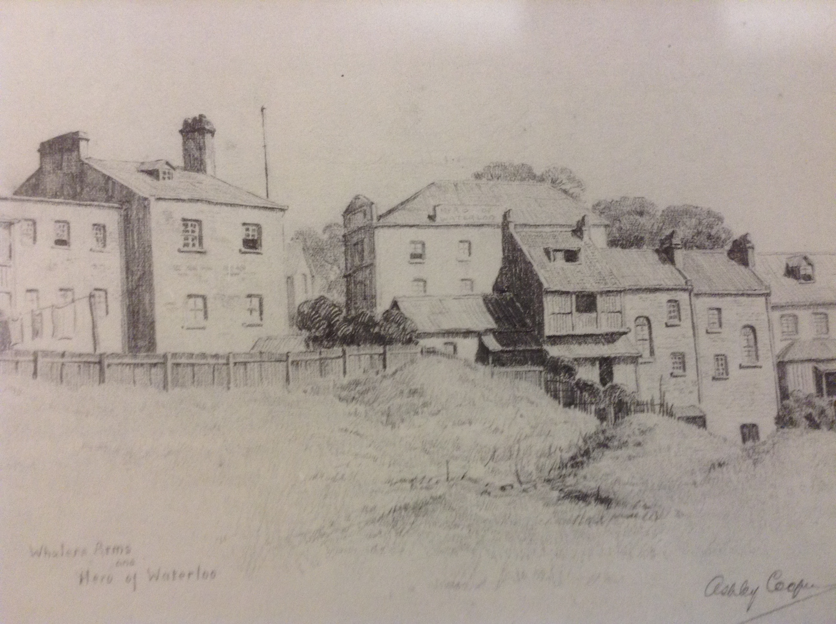 | 2. Convict Period Circa 1820  - Visiting an archaeological ruin to learn about a convict called Hugh Noble | - Identify reasons for the voyage of the first fleet and explain why various groups were passengers  - Investigate the everyday life of a convict  - sequence familiar people and evets  - locate relevant information from sources
12.45 -1.15 | Lunch (incl. walk to lunch) | Rocks Square or Cadmans Cottage Park
1.15 -1.45 | The Rocks Discovery Museum.  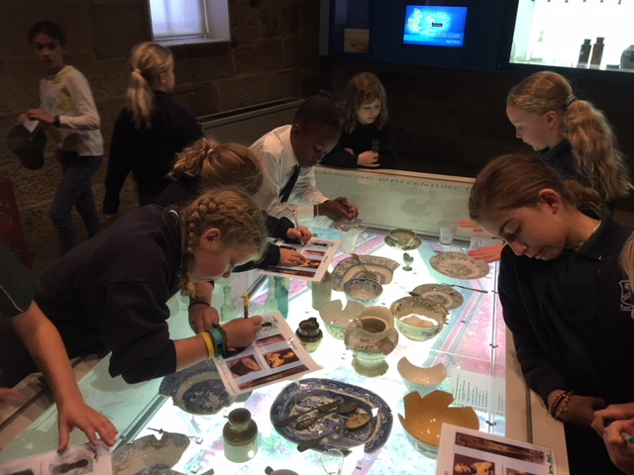 | 3. Rocks Discovery Museum Tour  - Students Visit the Rocks Discovery Museum and complete a mystery hunt to find and identify Aboriginal and Convict artefacts. | - Describe traditional Aboriginal ways of life  - Investigate the everyday life of a convict  - Sequence familiar people and events  - locate relevant information form sources
1.45 -2.15 | Walk to Argyle Place – End of Fieldtrip

