Enviromaths

Pre-visit activities and post excursion resources
Successful incursions have direct links to current classroom learning. Pre-visit activities carried out prior to the excursion will help students better understand their incursion content and provide connectedness and relevance to classroom learning.
To help students understand the Mathematics and Science concepts during their incursion, you may like to complete some of the pre-visit and follow-up activities below.

Student Pre-visit activities
Activity 1.
- Discuss the aims of the program ie to investigate how sustainable the school is, using maths and by conducting scientific investigations to assess the school’s impact on the environment in a 5 key categories.
- Explain the importance of working mathematically to gather data about school sustainability including auditing, tallying, analysing and displaying data, calculating averages and predicting.
- Discuss what sustainability means and why it is important to develop sustainable behaviours using examples (such as ways people can affect the environment under the headings air, water and biodiversity).
- Show the film clip ‘Its your choice’ which showcases school based strategies to improve sustainability.

Activity 2. Brainstorm session – identifying existing school management practices
Have students work in pairs to record the school’s existing sustainability practices in 5 key areas using ideas from the ‘Its your choice’ film clip and their own knowledge of school sustainability practices.
The key areas include:
- Biodiversity
- Energy consumption
- Water use
- Stormwater impacting on local waterways
- Waste

Activity 3. Ecological footprint calculation
Explain the concept of an ecological footprint ie the amount of land individuals need to provide them with all the resources they require and to remove all their waste. Students will calculate their ecological footprint using the calculator at: http://www.powerhousemuseum.com/online/bigfoot/
Class teachers will collate the individual student’s individual footprint results and calculate a class average. EEC teachers will use these results to discuss with students the most appropriate way to graph the number of hectares required to support each student’s lifestyle and how the class average compares with the Sydney average of approximately 7 hectares per person (or 5 planet earths if the entire world had this standard of living)

Activity 4. Biodiversity
Students will watch the wild classrooms film and answer questions in their workbook.

Activity 5.
Ensure students are familiar with the concept of auditing by tallying
Follow up Activities
Action planning/documentary
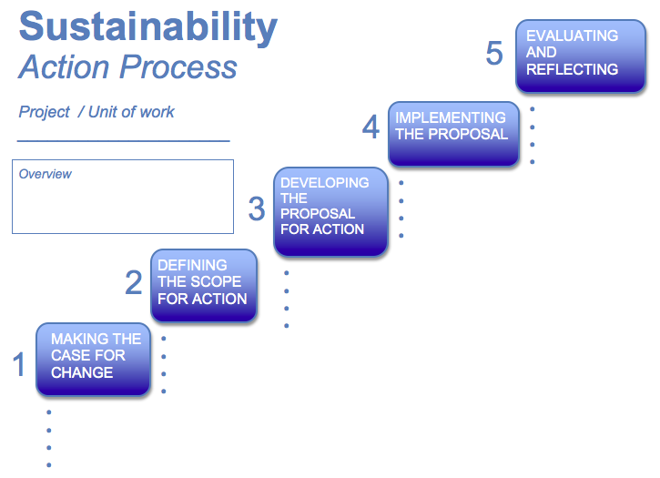
- Using the data from the sustainability investigations and the Sustainability Action process below, the class (and teacher) can decide which area of sustainability is to be targeted, and what format will be used to engage the school community.
- some schools may opt to make a documentary (powerpoint or movie) to raise awareness and educate the school community.

