Community and Remembrance

Pre-visit activities and post excursion resources
Successful excursions have direct links to current classroom learning. Pre-visit activities carried out prior to the excursion will help students better understand their excursion content and provide connectedness and relevance to classroom learning.
To help students understand the History concepts during their incursion, you may like to complete some of the pre-visit and follow-up activities below.

Student Pre-visit activities
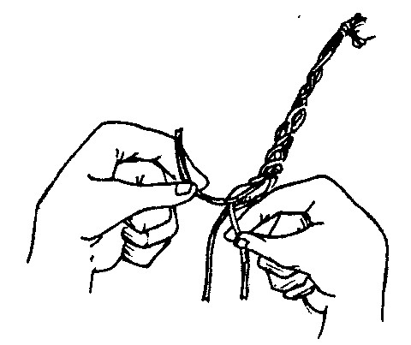
- Discuss Aboriginal peoples traditional lifestyles and how they used the environment
- Invite members from the local Aboriginal community to school to talk about their traditional culture
- Discuss what a convict was and why they were sent to Australia
- Read books such as My Place by Nadia Wheatley or Papa and the Olden Days by Rachel Tonkin that deal with the concepts of change and the passage of time
- Invite parents or grandparents to come and talk to the class about their childhood recollections
- Playing and comparing examples of Aboriginal, Colonial and modern day music

Follow up Activities
- Making a table showing different ways traditional Aboriginal children, convict children and modern children interact/ed with their environment under heading like food, water, shelter, waste, sewage, typical household items etc

