Bush Christmas

Pre-visit activities and post incursion resources
Successful incursions have direct links to current classroom learning. Pre-visit activities carried out prior to the excursion will help students better understand their incursion content and provide connectedness and relevance to classroom learning.
To help students understand the Science and Visual Arts concepts during their incursion, you may like to complete some of the pre-visit and follow-up activities below.

Student Pre-visit activities
- Discuss typical Christmas traditions like sending cards, sharing a Christmas lunch with family or giving presents
- Discuss terms associated with the environment such as native Australian animals, habitats or animal homes, pollution, litter and recycling
- Explore school gardens as habitats for birds and native animals and to collect gum leaves for gift tags
- Explain to students the importance of caring for school gardens and bushland by not playing in them or walking through them
- Identify some ways people can change the environment that can have a positive or negative impact on wildlife.

Follow up activities
- Discuss the themes of the Christmas story and let students illustrate their own version in a creative way such as a mural, mobile drawing or using a computer based drawing program such as ‘Draw’ or ‘Tux Paints’
- Practice the Christmas song to perform on an assembly and research other traditional Christmas songs
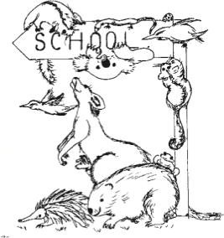
- If appropriate, establish a class garden, worm farm or compost bin or have a fund raiser to purchase a bird bath or have a frog pond installed.
- Introduce a new way to allow the class to reduce their impact on the environment, e.g. low waste lunch
- Organise a school grounds working bee with parents
- Identify a special place in the school playground to discuss an ongoing plan for continued care of that place
- Discuss students’ responsibility to help with and care for the environment and roles that could be introduced e.g. energy monitors, recycling etc
- Compile a collage of student’s drawings of themselves caring for special places.

