Sydney Metropolitan South Kitchen Gardens Program

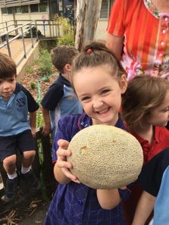
Observatory Hill Environmental Education Centre is seeking expressions of interest from schools interested in participating in a Kitchen Gardens Program. This sustainability initiative supports schools to run meaningful Kitchen Garden Programs, with support from “expert” EEC teachers. The program is based on the highly successful and engaging Penrith Lakes EEC Kitchen Garden Program which uses resources (with agreement) from the renowned Stephanie Alexander Kitchen Garden program.

What does it involve?
The Kitchen Gardens program involves students being engaged in one-hour cooking and gardening lessons each week for up to four classes per day. It is designed for students to achieve educational, wellbeing and sustainability outcomes through curriculum embedded, cross KLA lesson sequences. The program teaches a range of life skills, supports critical thinking, communication, problem solving and teamwork skills.

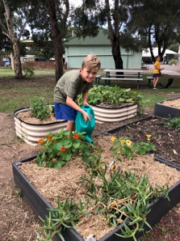
Why is it important?
Research shows that “children engaged in outdoor learning achieve higher scores in class tests, have greater levels of physical fitness and motor skill development, increased confidence and self-esteem, show leadership qualities, are socially competent and more environmentally responsible. When children experience the world through exploration and experiential learning activities in school grounds, these experiences can lay the foundation for shaping a child’s growing knowledge, confidence and identity”.
Karen Malone: Every Experience Matters.
The program will also complement your school’s welfare program, and adaptions to a likely long term future Covid-19 environment, by providing greater outdoor learning opportunities.

How does it operate?
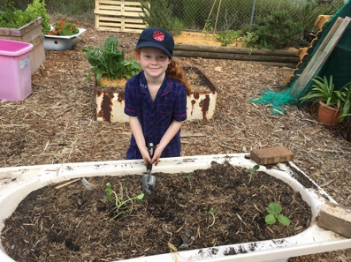
A specialist and NESA accredited Kitchen Gardens teacher is funded by your school, and would run the program, usually for one day a week per school. This teacher team teaches with your teachers and works with school support staff like the General Assistant. The appointed Kitchen Garden Teacher would coordinate the program for all stages including gardening set up, garden maintenance and cooking in the classroom. Up to 4 classes per day would be involved. The program costs $24,000 per year (one day teacher cost per year plus possible additional funds for garden set up and maintenance depending on current school gardens setup. Sustainable Schools Grants (round 3 & 4), could possibly help offset costs.

Observatory Hill EEC - NSW Department of Education

